
SRM Institute of Science and Technology
Mode of Exam
OFFLINE
College of Engineering and Technology
SCHOOL OF COMPUTING- ANSWER KEY
SRM Nagar, Kattankulathur – 603203, Chengalpattu District, Tamilnadu
Academic Year: 2022-23 (EVEN) SET B – ANSWER KEY
Test: CLAT-1 Date: 17.2.2022
Course Code & Title: 18CSC304J COMPILER DESIGN Duration: 1 HOUR
Year & Sem: III & V Max. Marks: 25

Q. No | Question | Marks
1 | a) {0} and {1,3,7} | 1
2 | d) %% | 1
3 | c.) 26 | 1
4 | c) 10 | 1
5 | c) bbbaaaa | 1
6 | 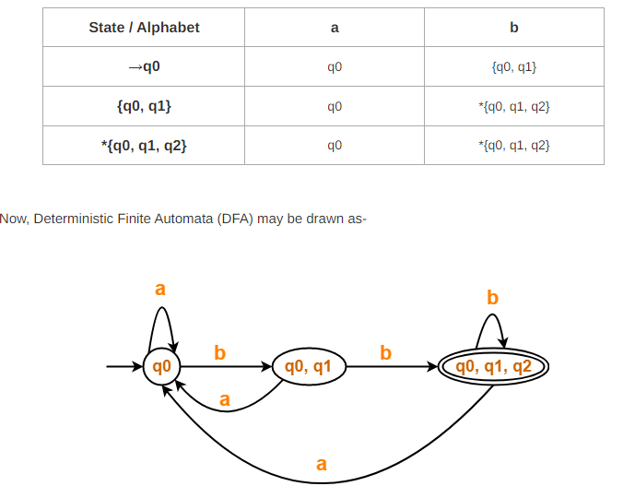 | 4
7 | 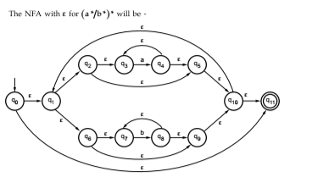 | 4
8 | 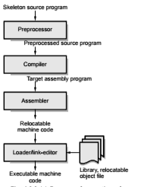 | 4
11 | 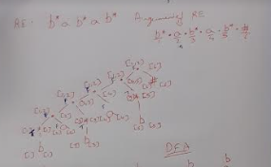  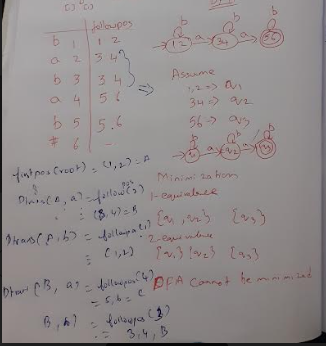 | 10
12 | - DFA with three consecutive zero’s  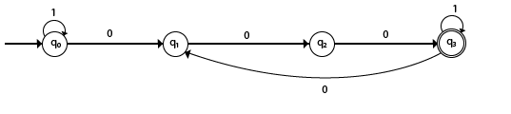  - Various operations of regular lanaguages  Let L, L₁, L₂ be subsets of Σ*  Concatenation: L₁L₂ = {xy | x is in L₁ and y is in L₂}  Union is set union of L1 and L2  Kleene Closure: L* = L^{i} = L⁰ U L¹ U L² U…  Positive Closure: L⁺ = L^{i} = L¹ U L² U…  iii)  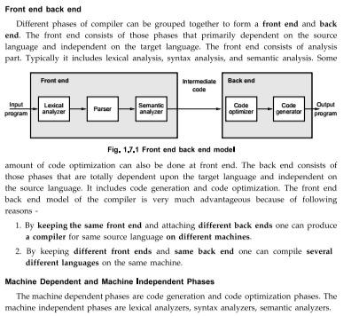 | 10

